
A 10
Sreenidhi Institute of Science & Technology
(An Autonomous Institution)
Code No: 101MA01/111MA01

B. TECH. I – Year I – Semester Examinations, February, 2014 (Supplementary)
ENGINEERING MATHEMATICS – I ( Common to all branches except BT )

Time: 3 Hours Max. Marks : 70

Note : No additional answer sheets will be provided.

Part-A (Objective Type)
Max.Marks:20

Answer all QUESTIONS.

1. Show that the P-series 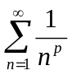, p>0 is convergent if p>1.
2. Test the convergence of series 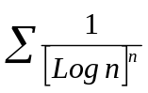.
3. Find the total differential of the functions Z=tan⁻¹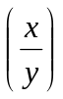, (x,y)≠(0,0).
4. If z=f(x,y), x=e^{2u}+e^{-2v} , y= e^{2u}+e^{2v} then find 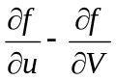.
5. Find the Eigen values of the matrix 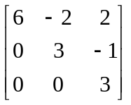.
6. Find the value of K such that the rank of the matrix 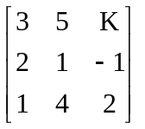is 2.
7. Evaluate the double integral 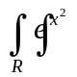dxdy, R : 2y≤x≤2 and 0≤y≤1.
8. Define spectrum of A and spectral radius of A with an example.
9. Find the radius of curvature at (0,c) of the catenary y = c Cosh (x/c).
10. Evaluate the integral 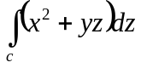, when "c" is given by x=t; t=t²; z=3t; 1≤t≤2.
Part - B
Max. Marks: 50

ANSWER ANY FIVE QUESTIONS. EACH QUESTION CARRIES 10 MARKS.
1. a) Test the series 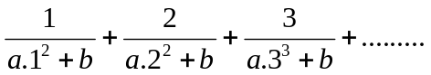 [5]
b) Test for convergence the series 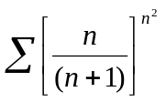. [5]
2. Find Maximum and Minimum values of .
3. Find the Eigen Values and Eigen Vectors of the following matrices 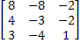 .

4. a) State and prove Cayley - Hamilton's theorem. [5]
b) Find a matrix B which reduces to the diagonal A=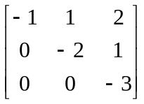 form by the transformation B A B⁻¹. [ 5 ]
5. a) Change the order of integration is a 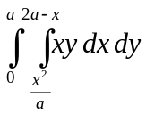. [ 5 ]
b) Find the volume of the forus generated by revolving the circle x²+y²=4 about the line x=3. [5]
6. a) Reduce the following matrices into Echelon form and find its rank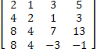. [5]
b) Solve the following system of equations using Gauss elimination method & if possible find the solutions [5]
x + y + 2z = 4, 2x –y +3z =9, 3x-y-z = 2.

7. a) If ρ₁ and ρ₂ are the radii of curvature at the ends of a focal chord of the parabola y²=4ax, then show that 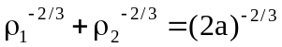. [ 5 ]
b) Find the envelope of system of concentric and coaxial ellipses of constant area.
[ 5 ]
8. If a<b, prove that 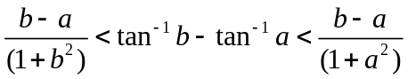 using Lagrange’s Mean value theorem. Deduce the following:
a) 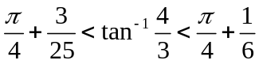

b) 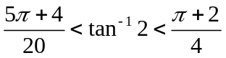

-- 00 -- 00 --

